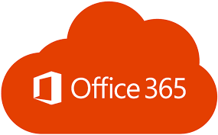

Office 365 domain name update

sigitglobal.onmicrosoft.com problem

Andrei Alex | GITO | 13.02.2017

# Introduction

We are currently having an issue with some accounts, where the domain name is not updated and it defaults to sigitglobal.onmicrosoft.com instead of the defined default domain in Office 365 (sig.biz). In this case we can’t even change the email addresses from the O365 console.

The reason is, with Active Directory (AD) synchronization enabled by default, it uses the proxy address field of the user sent from AD. If that is blank in AD it will use domainname.onmicrosoft.com.

If you try to manually populate it in AD, it won’t work.

There are two ways to address this problem. You can either use ADSIedit to modify the proxy address fields individually for each user, or you can use a PowerShell script and .csv file to do it in bulk.

# Using ADSIedit

Example:

https://www.mirazon.com/wp-content/uploads/2015/04/1-41.png

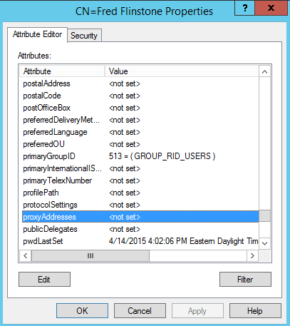Before making any changes:

Note: to see the proxyAddresses field, make sure that you do not have the “Show only attributes that have values” filter enabled when viewing the object.

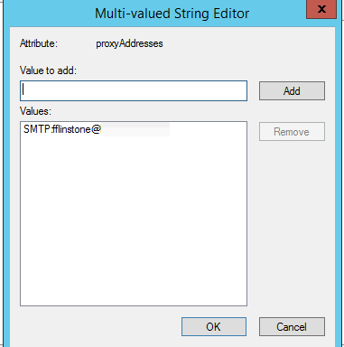

The populated proxyAddresses value:

SMTP in all caps denotes primary SMTP, lower case denotes secondary SMTP. After AD Sync happens, Office 365 will now let you change the user name on the settings screen:

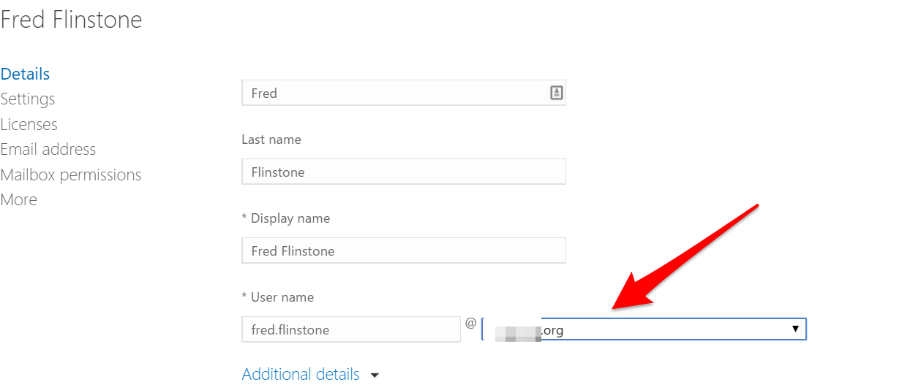

# Using Excel and PowerShell

Note: it will overwrite any existing proxyaddresses, not just SMTP: (primary). It will also remove SMTP: (aliases) if you run it as is. Additionally, if your “user logon name” does not match your “user logon name (Pre-Windows 2000)”, it will fail.

Create an Excel file with the following fields and export to a .csv called “c:\mailboxlist.csv”.

|  |  |
| --- | --- |
| name | ProxyAddress |
| kevin.oppihle | SMTP:kevin.oppihle@domainname.com |

Create a .txt file and input the following

*$users=import-csv C:\mailboxlist.csv  
foreach($user in $users){  
$u = Get-ADUser $user.name -Properties mail,department,ProxyAddresses  
$u.ProxyAddresses = $user.ProxyAddress  
Set-ADUser -instance $u  
}*

Save the file as “proxyemail.ps1″.

Open PowerShell as an administrator on your local AD server and run:

*./proxyemail.ps1*

You can then use ADSIedit to confirm the proxy addresses were assigned to the users.

With the next DirSync process, the updates should push to Office 365.

Here’s what the user will look like in Office 365 now:



Hope this helps.